**Sample Program**

<html>

<head><title>First Page</title></head>

<body>

<p>

Welcome to all

<pre>

This

is

our

first

page

</pre>

The

page

is

designed

using

HTML

</p>

<blockquote>

this is blockquote

</blockquote>

<h1>Authors of this page are </h1>

ABC <sup>1</sup>

DEF <sup>2</sup>

XYZ <sup>3</sup>

</body>

</html>

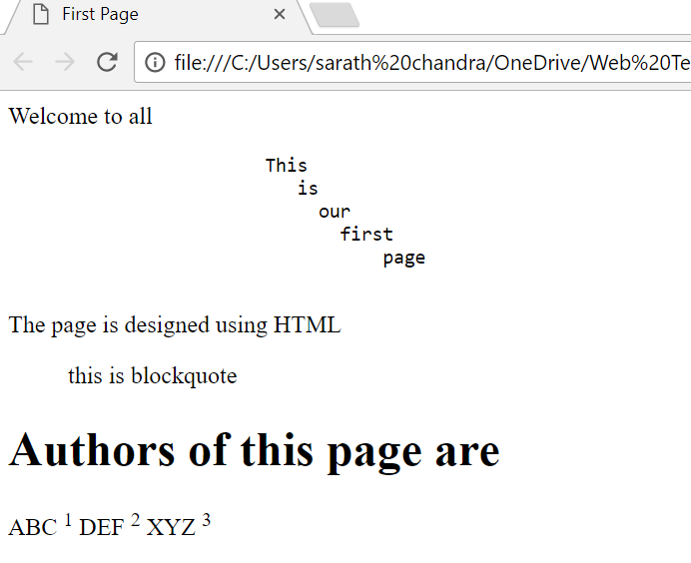

**Headings**

<html>

<head>

<title>Illustration of Headings</title>

</head>

<body>

<h1>This is H1 Style Heading</h1>

<blockquote><h2>This is H2 style Heading</h2></blockquote>

<blockquote><h3>This is H3 style Heading</h3></blockquote>

<h4>This is H4 style Heading</h4>

<h5>This is H5 style heading</h5>

<h6>This is h6 style heading </h6>

</body></html>

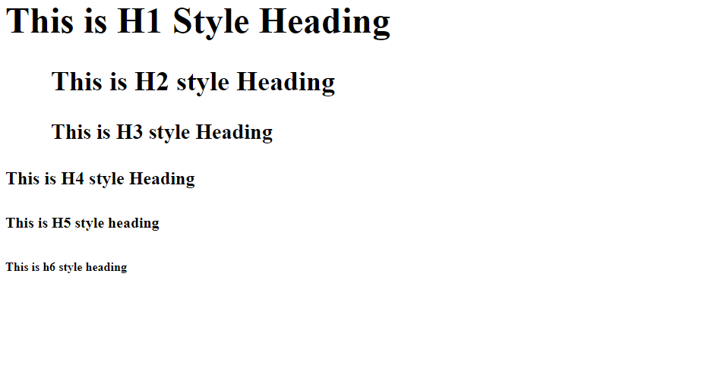

**Lists Program**

<html>

<head><title>Lists1</title></head>

<body>

<h1><center><u>Gitam..Deemed to be University</u></center></h1>

<br>

<ul>

<li>

<dl>

<dt><u>CSE:</u></dt>

<dd>Computer Science nad Engineering</dd>

</dl>

</li>

<ol>

<li>Staff</li>

<ol>

<li>Teaching Staff</li>

<li>Non-Teaching Staff

<ol>

<li>Technical</li>

<li>Non-Technical</li>

</ol>

</li>

</ol>

<li>Students</li>

<ol>

<li>Ist Year</li>

<li>IInd Year</li>

<li>IIIrd Year</li>

<li>IVth Year</li>

</ol>

</ol>

<li>

<dl>

<dt><u>ECE:</u></dt>

<dd>Electronics Communication and Engineering</dd>

</dl>

</li>

<ol>

<li>Staff</li>

<ol>

<li>Teaching Staff</li>

<li>Non-Teaching Staff

<ol>

<li>Technical</li>

<li>Non-Technical</li>

</ol>

</li>

</ol>

<li>Students</li>

<ol>

<li>Ist Year</li>

<li>IInd Year</li>

<li>IIIrd Year</li>

<li>IVth Year</li>

</ol>

</ol>

</ul>

</body>

</html>

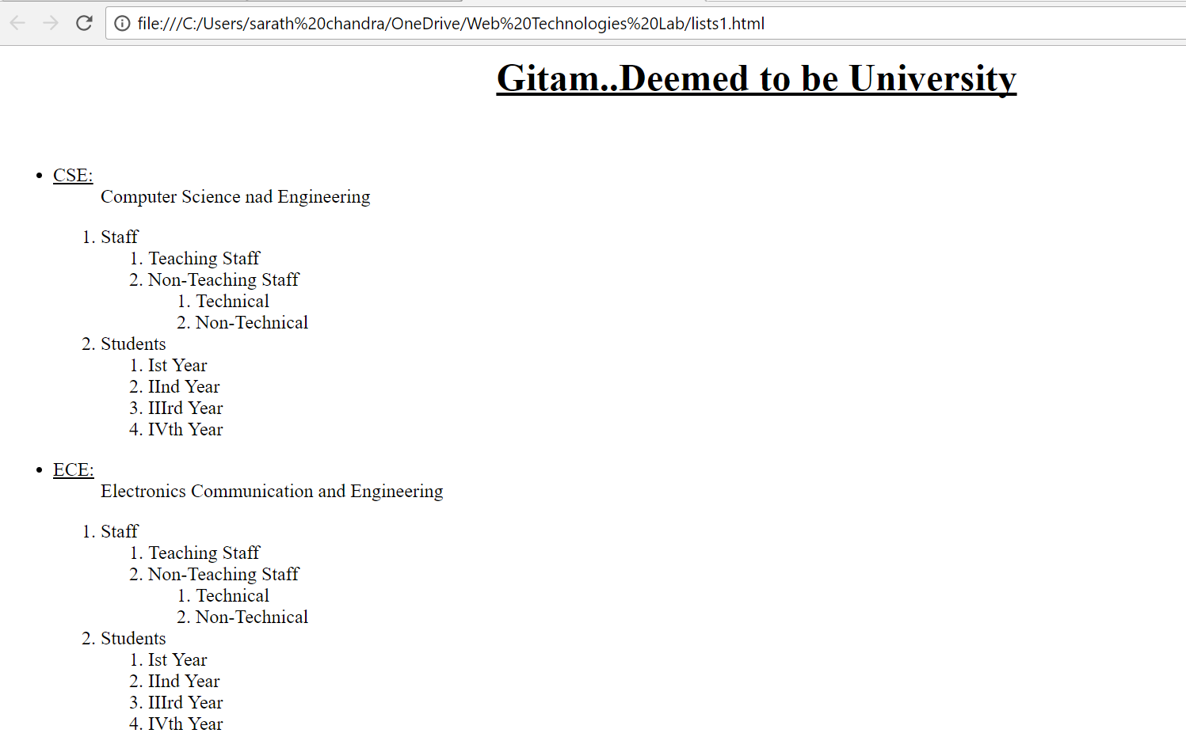

**Lists Program-2**

<html>

<head>

<title>Lists</title>

</head>

<body>

<h1><center><u>GITAM ..DEEMED TO BE UNIVERSITY</u></center></center>

<h3><center><u>Lists</u></center></h3>

<h3><u>Departments:-</u></h3>

<ul>

<li>

<dl>

<dt>CSE</dt>

<dd>Computer Science and Engineering</dd>

</dl>

</li>

<ol>

<li><a href="#first">First Year</a></li>

<li><a href="#second">Second Year</a></li>

<li><a href="#third">Third Year</a></li>

<li><a href="#fourth">Forth Year</a></li>

</ol>

<li>

<li>

<dl>

<dt>ECE</dt>

<dd>Electronics Comunication and Engineering</dd>

</dl>

</li>

<ol>

<li><a href="#firstECE">First Year</a></li>

<li><a href="#secondECE">Second Year</a></li>

<li><a href="#thirdECE">Third Year</a></li>

<li><a href="#fourthECE">Forth Year</a></li>

</ol>

</li>

<p id="first">

<h2>First Year of CSE</h2>

Create an excellent academic ambience that promotes innovation and research.

Impart quality education through well designed curriculum and experiential learning in tune with the changing needs of the industry.

Collaborate with world class academic institutions and software industries for mutual benefit.

Produce competent and socially committed graduates having creative skills and ethical values.

</p>

<p id=second>

<h2>Second Year of CSE</h2>

The department of Computer Science and Engineering was established in the year 1986. The department is committed to imparting quality education and producing highly skilled graduates who are in demand in the industry. Currently, the department offers B. Tech. (Computer Science & Engineering), M. Tech. (Computer Science & Technology) and Ph.D. Program along with Certificate Programme on Programming in Python. The curriculum is structured so as to strengthen the understanding of computer system concepts and enhance their computer skills and credentials. The programs of the department have been accredited by NBA. The thrust areas of research include cloud computing, data analysis and image mining. The department has been actively providing consultancy services to various public and private organizations.

</p>

<p id=third>

<h2>Third Year of CSE</h2>

The department possesses state-of-the-art infrastructure facilities for enabling learning to be made informative and holistic in nature. The department has ambient class rooms and air conditioned state-of-the-art laboratories. Each class room is equipped with ICT enabled learning technologies. The department has over 800 systems with 1 Gbps intranet and 2 Gbps Internet bandwidth connectivity and WiFi facility.The placement record has been near 100 percent with a salary range of Rs. 3.50 to 10.00 lakhs per annum. The major recruiters are Microsoft, Google, Yahoo, TCS, Accenture, Wipro, HCL, HP, Accenture, Mahindra Satyam, CSC, Capital IQ, CAP Gemini etc.

</p>

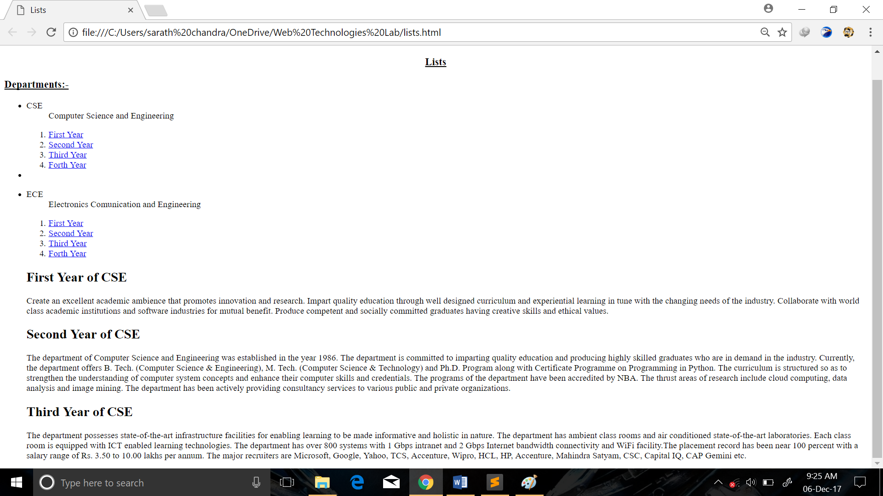

**Placement.html**

<!DOCTYPE html>

<html>

<head>

<title>Placement Portal</title>

</head>

<body>

<h3>Placement Requirements for CSE</h3>

<p id=#CSE>

<blockquote>GITAM organised an Achiever's Day function to hand over the offers of appointment to as many as 2,612 students of engineering, sciences, commerce and management and international business programmes at GITAM campus. </blockquote>

<br>

<blockquote>A total 300 companies visited GITAM campuses located in Visakhapatnam, Hyderabad and Karnataka to recruit students during the present academic year. Noted IT giant Tata Consultancy Services (TCS) itself recruited 755 engineering students from GITAM Visakhapatnam campus, One of the GITAM engineering final year students, S.Anirudh, was recruited by noted German Company UniTechTransfer GmbH-German centre for automation and robotics with high pay package of Rs 25 lakh per annum.

</blockquote>

</p>

</body>

</html>

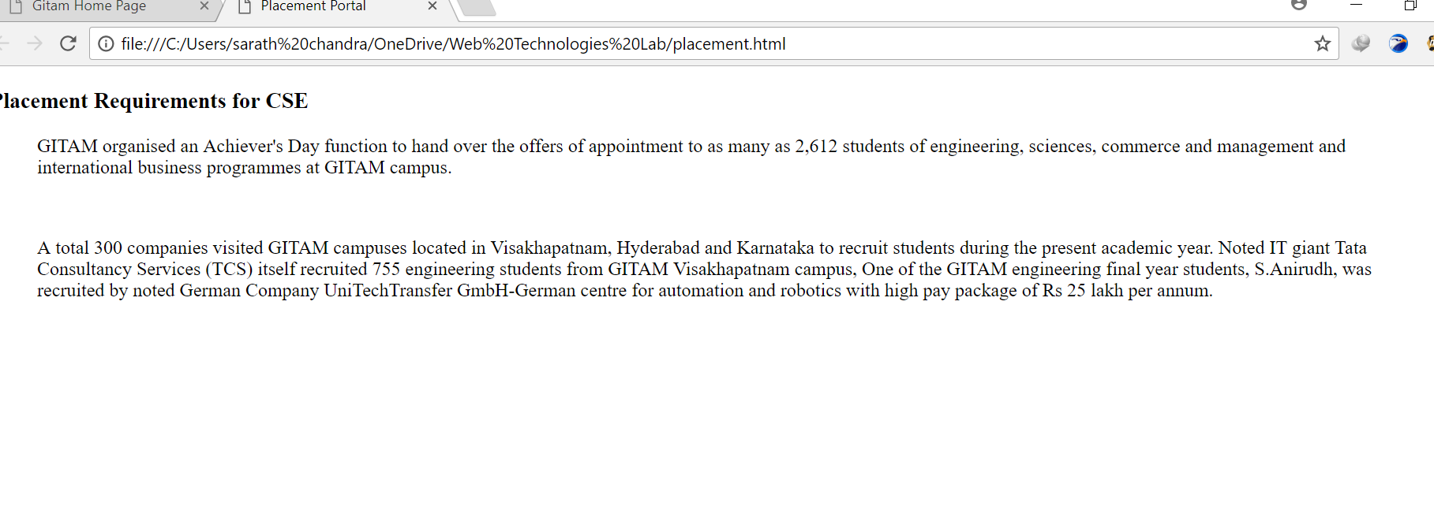

**Gitam Home page containing Gitam Logo**

<html>

<head>

<title>Gitam Home Page</title>

</head>

<body>

<h1><center><u>Welcome To Gitam University</u></center></h1>

<br>

<img src="logo-gitam-final.jpg" align="Left" alt="Gitam Logo is present">

<p>

GITAM University, one of top most colleges in South India. Eh okka course ni vadalakunda starting from Engineering till Medicine ikkada anni courses unnai. Management, Law, Pharmacy, Science ila anni courses ikkada unnai. GITAM ani muddhuga pilichina the full abbreviation of it is Gandhi Institute of Technology and Management. Founded by Ex MP Sri.Murthy garu, this university has been a home to many successful people over the years. Going strong even after 37 years, GITAM remains as one of the most popular institutions in Andhra Pradesh.Like every college, GITAM has its own swag. Right from the college atmosphere to the student achievements, ikada chadivina prathi student life it made its mark. Here are some reasons why it is so special!!

<br>

<blockquote>Alumni

Our Alumni Who are spread world wide in various sectors both in technical and management are tiers, part of prestigious organisations like the Union Public Services, IITs and IIMs, Stanford University, to name a few. They are CEOs of reputed firms in the US, UK, Australia and a host of other countries.</blockquote>

</p>

<p title=Alumini>

Our Alumni Who are spread world wide in various sectors both in technical and management are tiers, part of prestigious organisations like the Union Public Services, IITs and IIMs, Stanford University, to name a few. They are CEOs of reputed firms in the US, UK, Australia and a host of other countries.

</p>

<blockquote>

The Departments in Gitam are

<a href="#CSE">CSE</a>,

<a href="#MECH">MECH</a>,

<a href="#EEE">EEE</a>,

<a href="#ECE">ECE</a>

</blockquote>

<h2>Know about Ece branch</h2>

<p id=ECE>

The department started in the year 1981, became autonomous in 2003 and evolved as a constituent department in GITAM Institute of Technology, GITAM from 2007. The department is NBA accredited twice in the years 2002 and 2006. Students passout from this department with good placements and progression statistics.

The department has highly qualified faculty with high retention and varied specializations. It is well equipped with State-of-Art Laboratories.

<h3>Vision</h3>

To excel in education by imparting quality teaching and research to meet the challenges in Electronics and Communication Engineering

<h3>Mission</h3>

To impart technical skills, value based education to students, so as to enable them to face the demands of the industry.

To create innovative and instructional learning methods to hone the skills for solving problems of society.

To carry out research through constant interaction with R & D organizations and industry

To motivate the students to develop multidisciplinary technologies for a sustainable growth.

Curricular aspects The department undertakes the tasks of designing the curriculum, implementing the class work and laboratories, conducting the examinations, carrying out research and taking up consultancy works etc. The curriculum of different programmes is designed with Inputs from Academicians (from IITs/NITs), Industry personnel, students, Alumni, Parents and Researchers.

</p>

<h2>Know about CSE branch</h2>

<p id=CSE>

<h3>Vision</h3>

Excel in computer science and engineering education with international standards for global employment and research.

<h3>Mission</h3>

Create an excellent academic ambience that promotes innovation and research.

Impart quality education through well designed curriculum and experiential learning in tune with the changing needs of the industry.

Collaborate with world class academic institutions and software industries for mutual benefit.

Produce competent and socially committed graduates having creative skills and ethical values.

</p>

<h2>Know about EEE branch</h2>

<p id=EEE>

Welcome to the department of Electrical & Electronics Engineering at GITAM Institute of Technology, GITAM, Visakhapatnam. The Electrical & Electronics Engineering department is one of the oldest departments of the Institute which was established in the year 1980. Since its inception the department strives for excellence in teaching, research and professional services to the industry so as to achieve eminence in selected niche areas of Electrical and Electronics Engineering. The department has well equipped laboratories such as Electrical Machines laboratory, Power Systems Laboratory, Control Systems laboratory, Electrical Measurements laboratory, Power Electronics & Drives Laboratory, Electrical workshop & Computer laboratory. The department has undertaken a number of research projects/schemes with the financial assistance from UGC, DST and MHRD. The department is also actively engaged in research, consultancy and testing in the area of power systems.

<blockquote>The department offers four year B.Tech course in Electrical and Electronics Engineering, two year M.Tech course in Power System & Automation and Ph.D. in Electrical Engineering. Both B.Tech and M.Tech programmes attract the brightest students of the country and abroad every year. All UG & PG programmes of the department are accredited by NAAC with “A” Grade.</blockquote>

<blockquote>The department has been in the forefront of advanced research in the emerging areas of Electrical and Electronics Engineering and has also been very pro-active in interaction with industry and technology development. The department has been a catalyst in the growth and development of knowledge society. Further, state-of-the-art laboratory and infrastructure facilities effectively aid teaching and learning process.</blockquote>

</p>

<h2>Quiries about Placements?</h2>

please visit this <a href="placement.html#CSE">page</a>

</body>

</html>

